*BAGHLI & ARBASH INTERNATIONAL*

DEtailed Functional Documentation

Version 2.0

25/01/2017

VERSION HISTORY

|  |  |  |  |  |  |
| --- | --- | --- | --- | --- | --- |
| **Version #** | **Implemented**  **By** | **Revision**  **Date** | **Approved**  **By** | **Approval**  **Date** | **Reason** |
| 1.0 | Aniyan C | *11/01/2017* |  |  | Initial Documentation |
| 2.0 | Jyothi P |  |  |  | Modifications |

# Approval

The undersigned acknowledge they have reviewed the **Baghli & Arbash International Company** Functional Documentation and agree with the approach it presents. Any changes to this Requirements Definition will be coordinated with and approved by the undersigned or their designated representatives.

|  |  |  |  |
| --- | --- | --- | --- |
| Signature: |  | Date: |  |
| Print Name: |  |  |  |
| Title: |  |  |  |
| Role: |  |  |  |

|  |  |  |  |
| --- | --- | --- | --- |
| Signature: |  | Date: |  |
| Print Name: |  |  |  |
| Title: |  |  |  |
| Role: |  |  |  |

|  |  |  |  |
| --- | --- | --- | --- |
| Signature: |  | Date: |  |
| Print Name: |  |  |  |
| Title: |  |  |  |
| Role: |  |  |  |

TABLE OF CONTENTS

ProJect Documentation Approval 3

1. Introduction 5

Purpose of The detailed Specification Document 5

PROJECT OVERVIEW 5

2. Scope Of Work 6

3. Website Structure 6

4. Home Page 18

5. Custom Application-Online SHOPPING 29

6. User Flows 33

7. Order Processing Cycle 40

1. Introduction

## Purpose of The detailed Specification Document

This document provides a comprehensive and detailed architectural overview of the system design in order to give the development team guidance on architecture of the system to be developed. The Detailed Technical Design document is created during the Planning Phase of the project. Its intended audience is the Business Sponsors, Project manager, project team, and development team. Some portions of this document such as the user interface (UI) may on occasion be shared with the client/user, and other stakeholder whose input/approval into the UI is needed.

## PROJECT OVERVIEW

**Project title**

Baghli-Arbash Website - E-commerce

**Terminology**

* MAWAQAA – National Web Solutions Company
* UI/GUI – User Interface/Graphical User Interface. Portion of the product where the user sees and interacts with.
* UX – User Experience
* COD- Cash On Delivery
* QA – Quality Assurance. A planned and systematic process necessary to provide adequate confidence that the product optimally fulfils customer expectations
* Admin – Administrator/Administrator Section
* Project Owner – Mawaqaa Client or an authorized representative

1. Scope Of Work

The Scope of work will be covering Website Development in Content Management system with features of E-Commerce. There will be brand image listing and service, making the website accessible to every possible corner of the internet, generate inquiries, provide value add online services, and provide the company with a professional, dynamic image online.

The following are the functions of Custom Application for E-commerce

* Website Frontend will be available in English and Arabic
* Website will be responsive
* Stock Inventory will be managed with Baghli-arbash Inventory.
* Product Detailed Page(Zoom option)
* Searching Product
* Shopping Cart Functionalities (view, Add to cart, Check out)
* User Registration and Profile management
* Payment Integration will be through following gateways
  + Master Card
  + Visa Card
  + K-Net card

The Following are list of services incorporated in this development

* Banner Manager
* Mawaqaa Click Stat ( Web Stat )
* Natural Search Engine Optimization (SEO)
* Connection with ecommerce stock file
  + System need to be built using CMS

1. Website Structure

The following listed components are for website structure for Baghli & Arbash Website E-Commerce project.

Homepage components:

**1.1. Header**

1.1.1. Website Logo

1.1.2. Wish list

1.1.3. Sign In

1.1.4. Register

1.1.5. About us

1.1.6. Translator Button

1.1.6.1. Arabic

1.1.6.2. English

1.1.7. Search box

1.1.7.1. All Categories

1.1.7.2. Specific category

1.1.7.3. Brand

1.1.8. Shopping Cart

1.1.8.1. Number of items

1.1.8.2. Price

**1.2. Main Menu**

1.2.1. Home

1.2.2. Main Categories

1.2.2.1 X

1.2.2.2. Y

1.2.2.3. Z

1.2.2.4. Etc…

**1.3. Stick icons**

1.3.1. Social Media links (Facebook, Twitter, Google + and Instagram).

**1.4. Main Banner**

1.4.1. Images with/out URL (Internal / External)

1.4.2. Text for each and every image

**1.5. Featured Products**

1.5.1. List of products sliding/fading effect;

1.5.1.1. Product image

1.5.1.2. Product name

1.5.1.3. Price after/before [If there is a discount]

**1.6. New Arrival Products**

1.6.1. List of products sliding/fading effect;

1.6.1.1. Product image

1.6.1.2. Product name

1.6.1.3. Price after/before [If there is a discount]

**1.7. Most selling Products**

1.7.1. List of products sliding/fading effect;

1.7.1.1. Product image

1.7.1.2. Product name

1.7.1.3. Price after/before [If there is a discount]

**1.8. Tips & advices**

1.8.1. List of topics sliding/fading effect;

1.8.1.1. Topic image

1.8.1.2. Topic name

1.8.1.2.1. While click it will redirect the user to the details page of the topic.

1.8.2. See All [button]

1.8.2.1. While click it will redirect the user to the listing page of all the topics.

1.8.2.2. Tips/advertisements Videos as slider

**1.9. Accepted Payments**

1.9.1. Knet

1.9.2. Visa

1.9.3. MasterCard

**1.10. Footer**

1.10.1. Sitemap

1.10.2. FAQ’s

1.10.3. Subscribe Newsletter

1.10.4. Privacy Policy

1.10.5. Social Media links (Facebook, Twitter, and Instagram).

1.10.6. Sitemap, About us, Contact us, FAQ’s, Tips & advices , Privacy Statement, Terms and Conditions (Quick links)

**2.Sign In**

2.1. Email

2.2. Password

2.2.1. Stay Signed in (ticked by default)

2.2.2. Forgot your password?

2.2.2.1. While clicking it will redirect the user to reset password page, using the user email ID.

2.2.2.2. Proceed [Button]

2.2.2.2.1. Sending reset link to the user for reenter new password

2.3. Sign in [Button]

1. **Register Page**

3.1. First name*

3.1. Last name*

3.2. Mobile number*

3.3. Password*

3.5. Re-enter Password*

3.6. Email*

3.7. Recovery Email*

3.7. Phone number

3.8. [Checkbox] I agree to Terms and conditions [while click it will redirect the user to terms and conditions page] [new tab]

3.9. [Checkbox] Subscribe to our Newsletter (ticked by default)

3.10. Register [Button]

3.10.1. Note: there is Buy as guest option so that the users can buy products without registering to the website

**4. Wish list Page**

4.1. Listing Page of products

4.1.1. Added while clicking on any products [Add to wish list] button.

4.1.2. There will be sorting by [Best Match, Most selling and Most rated]

4.2. Each product consists of;

4.2.1. Image

4.2.2. Name

4.2.3 Brand Name

4.3.4 Date [Added to wish list]

4.3.5 Delete[Button]

4.3.6 Choose Colour

4.3.7 Choose Size

4.2.8. Price after/before [If there is a discount]

4.2.9. Number of views

4.2.10. Rating [Stars] Number of votes

4.2.11.Free Shipping Text [If applicable]

4.2.12.Out of Stock Label[ If applicable]

4.2.13 Discount %

**5. Shopping cart Page**

5.1. Listing Page of products

5.1.1. Added while clicking on any products [Add to Cart] button.

5.1.2. Minimum Order Value

5.2. Each product consists of;

5.2.1. Image

5.2.2. Name

5.2.3. Small Description

5.2.3. Price after/before [If there is a discount]

5.2.4. Quantity

5.2.5. Discount % ( upper right)

5.2.6. Rating [Stars] Number of votes

5.2.7 Delete[Button]

5.2.8. Save for later [Button]

5.2.9 Total Price

5.3. Delivery Charge

5.4. Total Price after/before [If there is a discount]

5.5. Grand total Price [Final]

5.6. Buy All [Button]

5.6.1. While click it will redirect the user to review order page

5.6.2. Selecting exiting address or add new address.

5.6.3. Products review

5.6.3.1. Each product consists of;

5.6.3.1.1. Image

5.6.3.1.2. Name

5.6.3.1.3. Price after/before [If there is a discount]

5.6.3.1.4. Quantity

5.6.3.2. Delivery Charges

5.6.4. Place the order [Order has to exceed the minimum order value]

5.6.4.1. To redirect the user for payment

5.6.4.1.1. Knet

5.6.4.1.2. Visa

5.6.4.1.3. Master Card

5.6.4.2. After payment done;

5.6.4.2.1. If successful

5.6.4.2.1.1. Receipt will be issued with all the details of the order and status as [Successful]

5.6.4.2.2. If rejected

5.6.4.2.2.1. Receipt will be issued with all the details of the order and status as [Rejected]

**6. List page for [Categories,Brand] Listing Page**

6.1. Filter & sorting functionality based;

6.1.1. Products key words [text box] for searching in that specific list

6.1.2. Best Match

6.1.3. Newest 6.1.4. Most selling

6.1.5. Most rated

6.2. Each product consists of;

6.2.1. Product Image

6.2.2. Product Name

6.2.3 Brand Name

6.2.4 Choose Colour and Size

6.2.5. Price after/before [If there is a discount]

6.2.6 Quantity

6.2.7 Viewed Number

6.2.8. Free shipping text[If applicable]

6.2.9. Rating [Stars] Number of votes

6.2.10. Out of stock label [if the item is out of stock]

6.2.11 Add to cart [Button]

6.2.12 Add to wish list [Button]

6.2.13 Discount % ( upper right)

6.3. Pagination functionality [1,2,3,5, etc…]

6.4. Related Products

6.4.1. List of product marked as related to that specific list

6.4.1.1 Each product consists of;

6.4.1.1.1. Product Image

6.4.1.1.2. Product Name

6.4.1.1.3. Price after/before [If there is a discount]

**7. Product details Page for [All the products]**

7.1. Product directory starting from home page [Home > Category name > Product short name]

7.2. Product Images [Big Image and slider for small images]

7.3. Product Name

7.3. Product Small description

7.4 Brand Name

7.4. Rating [Stars] Number of votes

7.5. Number of orders

7.6. Price

7.7 Before Price

7.8 Free Shipping Text

7.7. Discount Price [If there is a discount]

7.8. Quantity

7.9 Choose colour and size

7.9. Out of stock label [if the item is out of stock]

7.9.1. In that case add to cart button will be disable and instead of it will add one button for notify the user once the item come to stock.

7.9.2. If the user click on notify me system will check if the user is already signed in system will give a pop telling the user that we will send you notification once the item back to stock

7.9.3. If the user not signed in system will redirect the user to login page to sign in or register .

7.10 Add to Cart [Button]

7.11 Add to Wish list [Button]

7.12 Buy Now [Button]

7.13. Product Details

7.13.1. Product Description

7.13.2. Photo Gallery

7.13.3. Video Gallery

7.13.4. Tips & Advices for that specific item

7.13.5. Available colors and sizes for the same corresponding product (if any)

7.14. Like button [user can click on that button to like the item and the system will calculating the numbers and display it in the page.

7.15. Customers Reviews [How many review]

7.15.1. Name of Customer

7.15.2. Order information

7.15.3. Review text

7.15.4. Number of stars voted

7.16. Related Products

7.16.1. List of product marked as related to that specific list

7.16.1.1.1. Each product consists of;

7.16.1.1.1. Product Image

7.16.1.1.2. Product Name

7.16.1.1.3. Price after/before [If there is a discount]

7.17. You May also like

7.17.1. List of product marked as related to this specific product

7.17.1.1 Each product consists of;

7.17.1.1.1. Product Image

7.17.1.1.2. Product Name

7.17.1.1.3. Price after/before [If there is a discount]

**8. User Profile Page**

8.1. Account Dash board

8.1.1. Hello Full name

8.1.2. Personal information

8.1.2.1. Full Name

8.1.2.2. Email

8.1.2.3. Mobile number

8.1.2.4. Phone number

8.1.3. Delivery Address [Default]

8.1.3.1. Address Name

8.1.3.2. Address Information

8.1.3.3. Phone number

8.2. Manage Information

8.2.1. Personal Information

8.2.1.1. First Name

8.2.1.2. Last Name

8.2.1.3. Mobile number

8.2.1.4. Phone number

8.2.1.5. Email

8.2.1.6. Delivery Address [Default]

8.2.1.6.1. Address Name *

8.2.1.6.4. Area*

8.2.1.6.4. Block*

8.2.1.6.5. Street*

8.2.1.6.6. Avenue

8.2.1.6.7. Building Number*

8.2.1.6.8. Floor Number

8.2.1.6.9. Flat Number

8.2.1.6.10.Comments

8.3. Addresses book

8.3.1. Delivery Address [Default]

8.3.1.1. Address Name *

8.3.1.2. Area*

8.3.1.4. Block*

8.3.1.5. Street*

8.3.1.6. Avenue

8.3.1.7. Building Number*

8.3.1.8. Floor Number

8.3.1.9. Flat Number

8.3.2. Add New address

8.3.3. Set specific address as default functionality.

8.4. Orders

8.4.1. Listing page of Open orders and Previous Orders

8.4.2. Sorting by [Order Status]

8.4.2.1. Each product consists of;

8.4.2.1.1. Order ID

8.4.2.1.2. Order Time & Date

8.4.2.1.3. Order status [Ongoing-Completed]

8.4.2.1.4. Order Amount

8.4.2.1.5. During [Value of days] user can give the following for the completed Orders

8.4.2.1.5.1. Giving Votes [Stars]

8.4.2.1.5.2. Giving Review

8.5. Change password

8.5.1. Current password*

8.5.2. New Password*

8.5.3. Confirm New Password*

1.1.1. Social Media links (Facebook, Twitter, and Instagram).

1.1.2. Sitemap, About us, Contact us, FAQ’s, Tips & advices, Privacy Statements, Terms & Conditions(Quick links)

**9. FAQ’s Page**

9.1. Page for all the questions and answers related to website.

**10. About Us Page**

10.1. Corporate Overview

**11. Contact Us Page**

11.1. Contact / Address information / Location on Map / Hotline

11.1.1 Call no. should be clickable which will show on mobile to call

11.1.2 Comments should not have limitation

11.1.3 Once submit it should show " Thank you for contacting Us , we will contact you in 2 working days"

11.2. Feedback/ Inquiry form

11.2.1. Name

11.2.2. Email

11.2.3. Phone Number

11.2.4. Other Number(optional)

11.2.4. Text Box (details)

1. Home Page

The following are the home page components in detail.

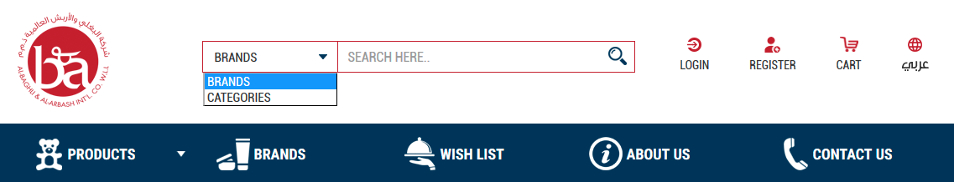

* Search by Brand and Search by Category are possible.
* Cart will show the value of all products purchased. On clicking my cart, this will show the shopping cart with all products and this can be checked out.
* About us- This will take user to about us Page
  + This page can be edited with html editor.
  + Images can be also inserted to about us page.
  + Our Business Partner- Hidden/ show property managed by Admin

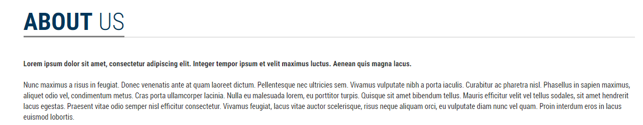

* Search – This will take user to product listing page regardless of category, specific category and Brands
* Login
  + Sign in – Register



* + After user Login: Hello [Full Name] - **Sign out - my basket icon -** 
    - Personal Information
    - Delivery Address
    - Address Book
    - Orders
    - Change password
* Translator Button- website can translate into Arabic / English

Category Management

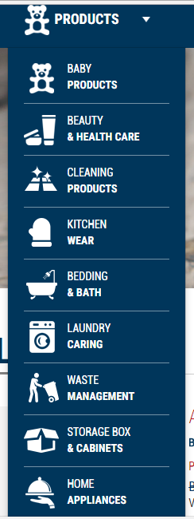

* Categories can be added

Banner Management



* Multiple Banner Images can be added from admin side
* On clicking banner can take user to external / internal link
* There is no limitation for addition of banner in this area
* Start date and end date can be added to each banner
* Text for each and every image
* Banner sliding interval can be set from admin side

New Arrivals

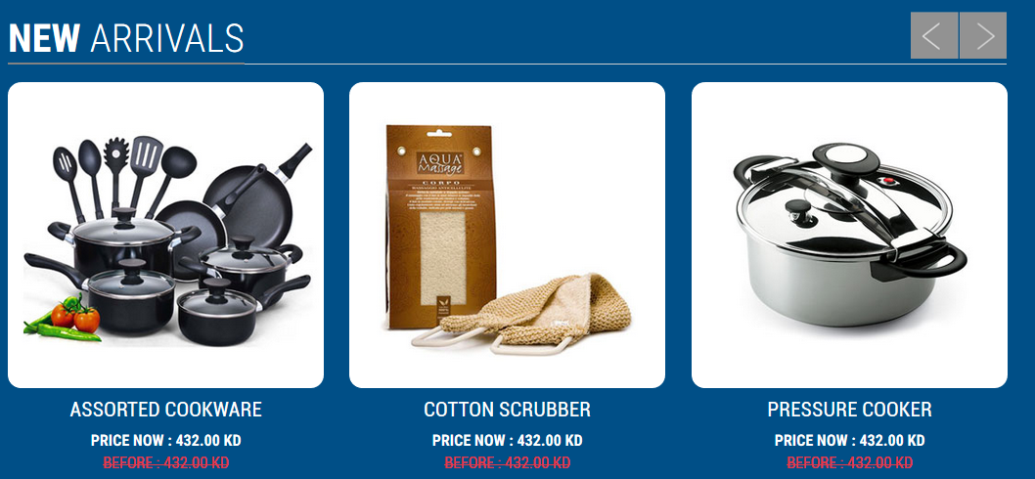

While adding a product, products can be tagged as New Arrivals

* This will show multiple products regardless of their category
* On clicking this banner will take user to product detailed page
* New Arrival will have start date and end date
* This product list will be regardless of category or Brands
* Product price display after/before (if there is discount).
* This product list will be sliding if more than three products are added
* Admin can hide this section, if no new arrivals are there.

Featured Products

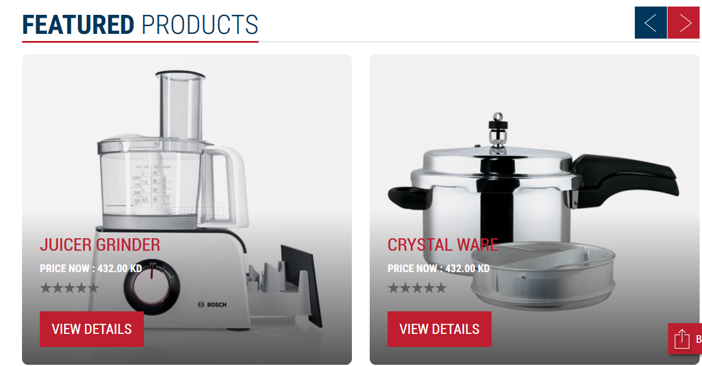

* This will show products
* This product list will be sliding if more than two products are added
* Products can be assigned to this section of home page by selecting with checkbox. While adding or editing product, admin is allowed a check box to show this product as featured products. This area will list only products with this checkbox selection.
* View details will navigate user to product details page
* Product list in this section will be regardless of brand or category
* Rating view for the particular product.
* Product price display after/before (if there is discount).
* Admin can hide this section, if no featured products are there.

Tips & Advices



* Home Page tips and advices can be manage from admin side. Admin can select which all tips should be visible in home page.
* Tips & Advices section will show the tips to the customer about the products in Baghli & Arbash e-commerce website.
* Tips will slides and customer can have a look.
* Customer can view all Tips & advice by clicking on “View All” button . All tips & advices are displayed in the navigated page. Customer can click on the tips and it will redirect to the detailed description about the clicked tips & advice.
* Detailed description and related videos are in the detailed page.
* Videos can be slide if it more than four, and this page have a back button to go to tips & advice page.
* There are two categories , 1- product depends and 2- is general Tips and advice, Admin have the permission to add tips and advice corresponding to the products depends or general tips. There are delete and edit tips also available.
* Listing page of Tips and Advices should have a filter for selecting the category.

Best Sellers

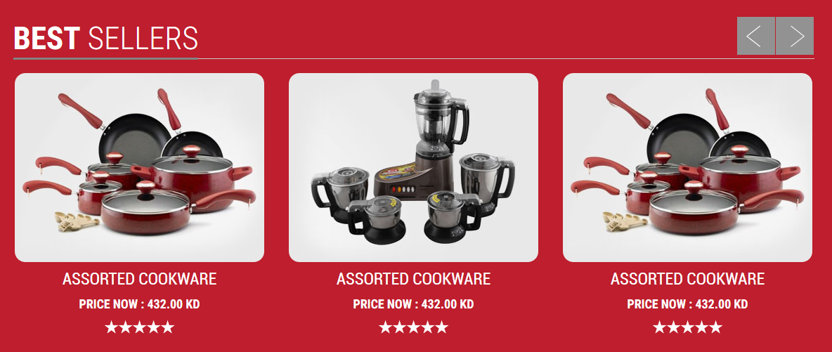

* This product list will be regardless of category or Brands
* There will be option to show product in best Seller (upon the calculation of best seller, this product will be displayed automatically).This calculation will only take products that are marked as best seller only
* There will be an option to override and show the product in best seller. This Product will be displayed without any calculation. This will have start date and end date.
* This section will be auto sliding for products more than three
* Product price display after/before (if there is discount).
* Admin can hide this section, if no best sellers are there.

Brands List



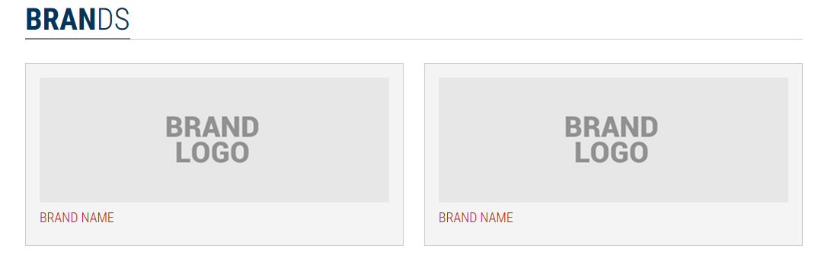

* This will list all brands
* Display brand logo , brand name and brand description

Wish List

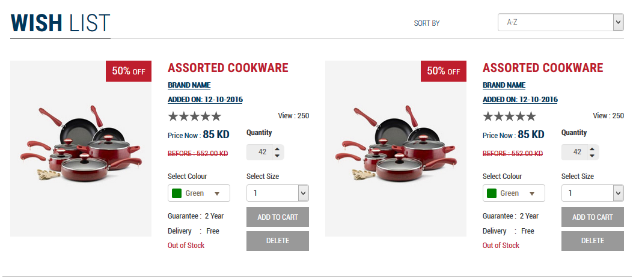

* Wish list screen will appear after clicking the Wish List button from Home page at top header area. Here the customer can view the items that He wish to buy.
* Customer will get add to wish list option in the product details page, item will be in the wish list until He remove it. Delete option is provide each items in the wish list.
* When the wish list items are added to shopping cart the items will automatically remove from wish list and added to shopping cart.
* Each item in the wish list should have item Name, Brand Name, Price, Colour, Size before and current, number of views, star rating, availability, added date, Delete button (this can use to remove an item from the wish list), Add to cart button, Free shipping text, Out of stock label.
* Quantity updating option is there in wish list, once the customer click on “add to cart” button from wish list then it will move into Cart and customer can continue the place order.

Footer

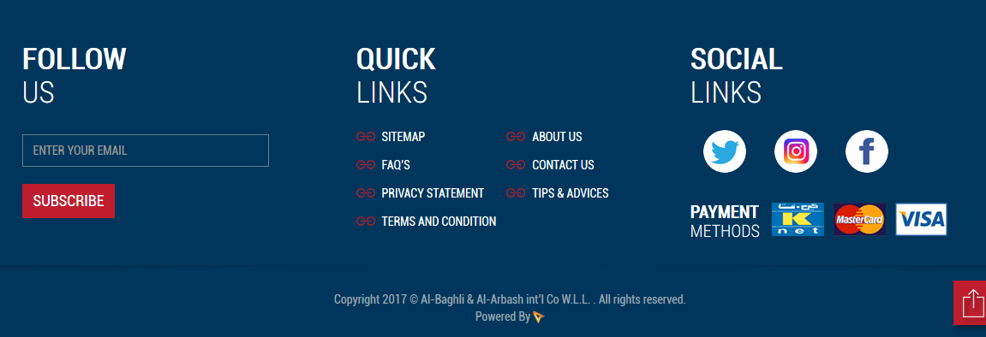

* Page links can be added. Maximum of 8 links can be added in quick links section.
* These links will be page links – external and internal links
* In Social Links section, different social media like,
  + Twitter
  + Instagram
  + Facebook
* In Payment Methods, different payment options method is displayed (Knet, MasterCard and Visa).
* Follow Us – Will have a list of all subscribers. Newsletter can be composed and send to all subscribers. Type the email address in the given area to subscribe the newsletter.
* Quick Links
  + Sitemap – navigate to sitemap

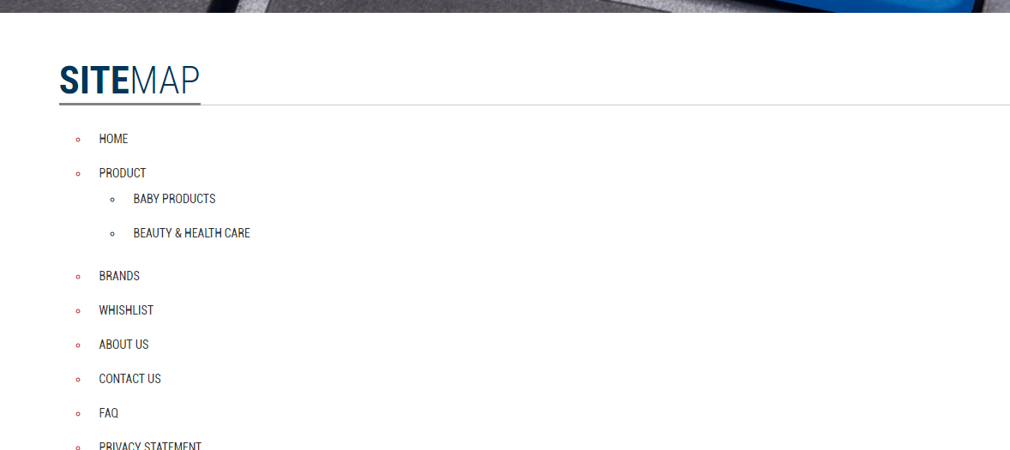

* + Faq’s- navigate to FAQ page

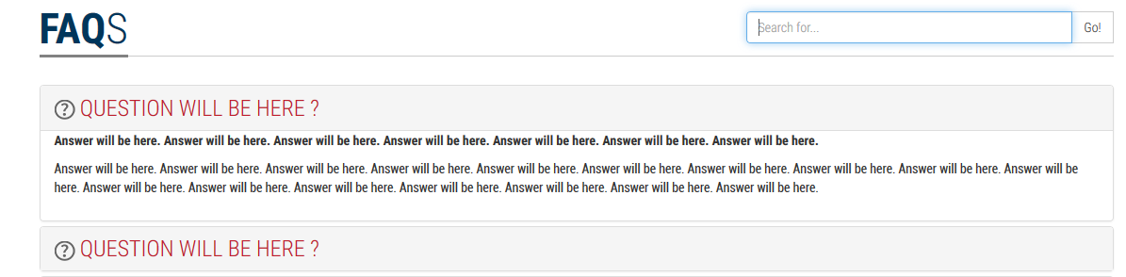

* + Privacy Statement – navigate to privacy statement of the company.

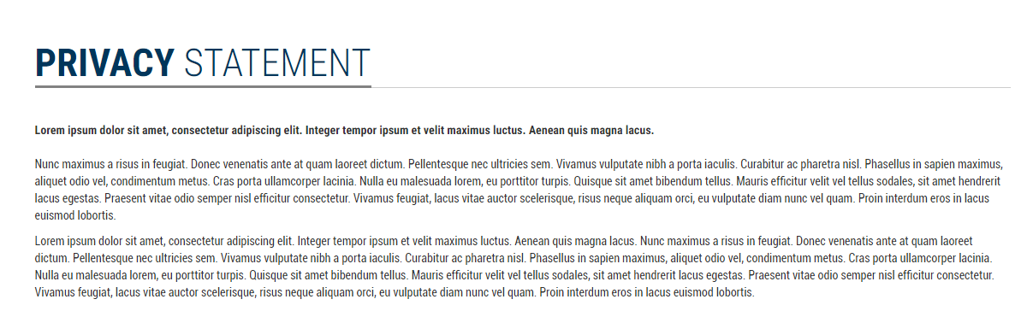

* + Tips & Advices- navigate to tips & advice list page
  + About Us
  + Contact Us
  + Terms & Conditions



* Footer Links Privacy Statement, about us, Sitemap,Terms & Conditions cannot be managed and only page contents of these pages can be managed.

1. Custom Application-Online Shopping

The following are the custom Shopping cart features. Price and Stock of products will be based on material ID specified in Shopping cart. The stock info will be checked for every transaction processed with system

Category Listing

Content Management System can handle Category /Products Addition and Editing of Currently considered categories are the following.

* + Baby Products
  + Beauty & Health care
  + Cleaning Products
  + Kitchen Wear
  + Bedding & Bath
  + Laundry Caring
  + Waste Management
  + Storage Box & Cabinets
  + Home Appliances

On clicking of each category, user will see the category related information will list of Brands associated with each category and products for each category.

Brand Listing

* Content Management System can handle addition of Brands, Brand Images.
* Pagination is needed if the brand exceed count of 8.

Product Listing

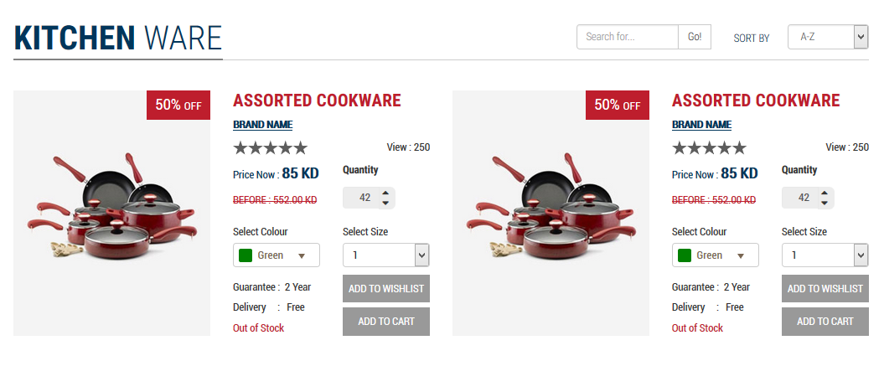

* Content Management System can handle addition of Products, Products Images. Multiple Product image can be added
* On brand name click, redirect to product listing page of that brand.
* Rating votes like are added
* Discount Percentage at the top of the product image.
* Customer can update the quantity by selecting the dropdown and up option.
* Product options like colour and size is depends to the type of product category.
* Add to cart, add to wish list options.
* Add to cart- add the products in to the cart later the customer can buy this item. Move to wish list denotes that the item is wish by the customer but He may not like to buy now, so it will go to the customer’s wish list location.
* Size and colour of the product can be manageable from admin side
* Each Product will have a material id. This id is unique for each product. Same product with different colour/size will have different material id.

Product Details

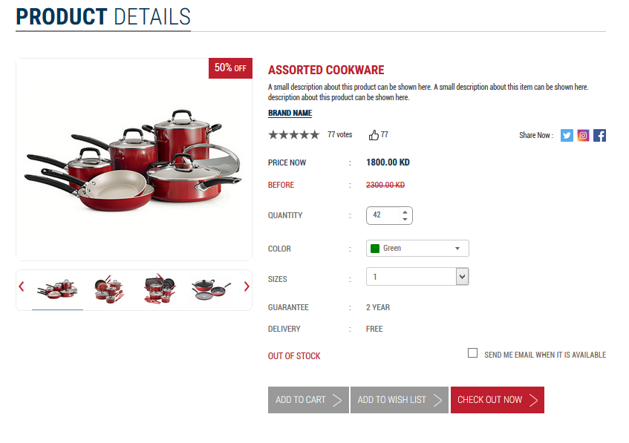

* Zoom Effect are available for Product images
* Content Management System can handle addition of Products, Products Images. Multiple Product image can be added
* Product image listing will also have magnifying effect for images on mouse hover
* Rating votes like are added
* Discount label (upper right).
* Customer can update the quantity by selecting the dropdown and up option.
* Product options like colour and size is depends to the type of product category.
* Add to cart, add to wish list and buy now options.
* Add to cart- add the products in to the cart later the customer can buy this item. Move to wish list denotes that the item is wish by the customer but He may not like to buy now, so it will go to the customer’s wish list location. Buy now redirect to the checkout page.
* “Share this page to a friend” option will be there.

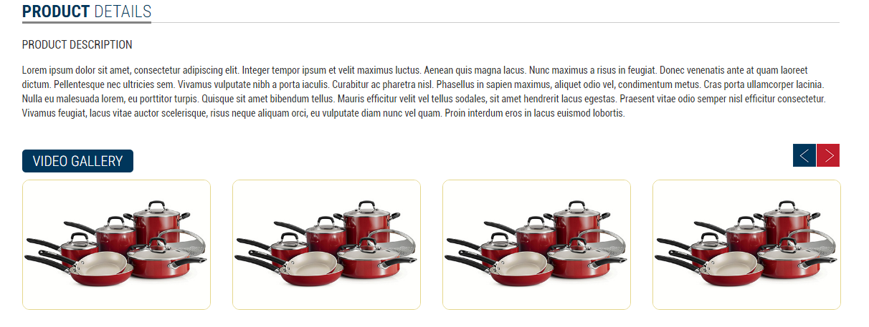

* There will be a column to view the description about the specific product and a video gallery on the product it will slide if the image more than 4.

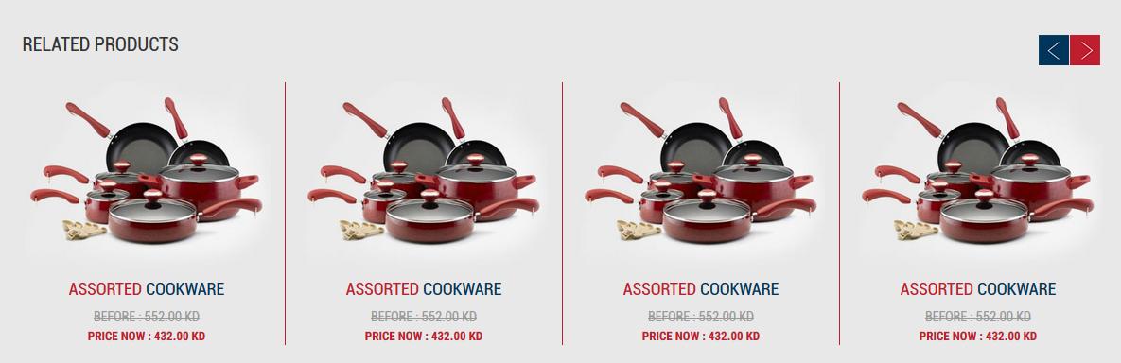

* There will be a column display related products in product detailed page. This should be managed from the admin panel.
* Related product should be selectable by admin from any category.

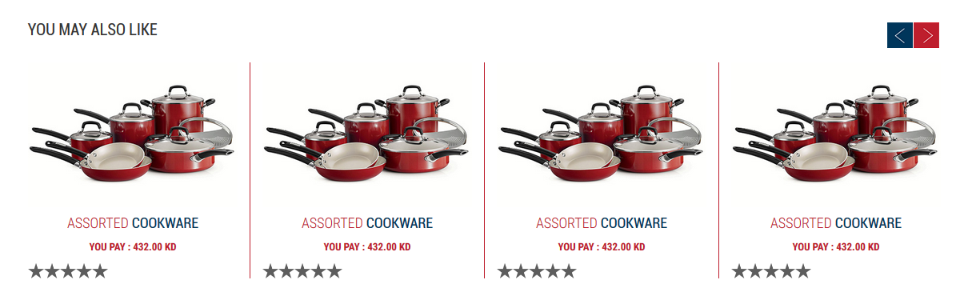

* There will be a column display alternative products (you may also like) in product detailed page. It will help the customer to reach the product which they are searching, it will increase the chance of selling, this should be managed from the admin panel.

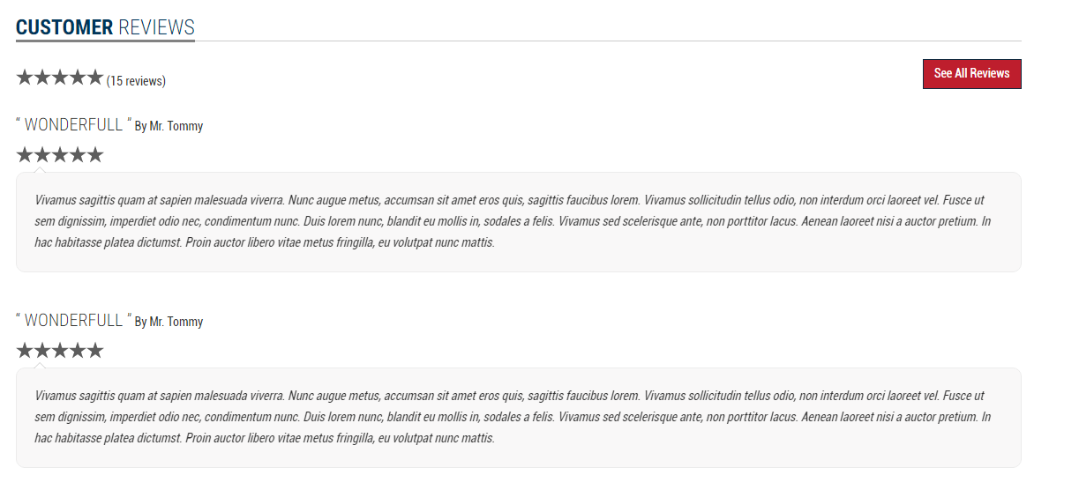

* There will be a column display the customer reviews related to the corresponding product. See all Reviews will navigate the customer to all review page.
* Admin can manage user comments. Admin should have the option to hide bad comments from displaying in details page or they can block the user.



* There will be a column display Tips & Advices related to the particular product item.
* These tips and advices can managed from admin side.

1. User Flows

* User clicks a category:
  + Sub categories will be listed
  + On clicking category or sub category, the items under the category appear in Alphabetical order
  + There will be options on top to sort by: price, new arrivals
  + There will be a tag with product as New for products that are entered to this system. Date is calculated as 30 days from created date for products. Products which are marked to show as new arrivals will be shown.
  + On clicking an item, an item details page appear:
    - Big image with thumbnails under it for different angles images.
    - Price
    - Available in stock or not
    - If the stock is “0” the “Sold Out” sign will show but the user still can place request for this product. This product will not be added to shopping cart
  + Text Box will be there to enter Quantity (integer only)
  + [Buy] button – Proceed to check out for logged in user or this will take user to screen login or continue as guest
  + [Add to cart] button – This will show the product addition in Cart. Cart Amount will be changed in Header section on Top.
  + Request information about the item 🡪 small form to request info about the item- This will be enjoyed by registered user and guest user
  + Related items 🡪 for each Product addition, Material Ids of related products can be added. If no products are added, this section will stay as hidden
  + Alternatives/ You may also like , if the item is out of stock- For each Product addition, Material Ids of alternative products can be added. If no products are added, this section will stay as hidden
* User clicks on [Buy] button in any item will be proceeded with following steps
  + This will take user to checkout page if user is logged in
  + If user is not logged in, User can Login to existing account or register or continue as Guest
  + Then a screen with the item appearing with price & with option to control quantity
  + Then to choose Delivery address or add new address
  + Then to choose payment method:
    - K-Net / Visa / MasterCard
    - Cash on delivery (For Registered User only)
* User clicks on shopping basket:
  + Proceed to check out for logged in user or this will take user to screen login or continue as guest
  + A screen with all items that were added to basket show up with price & with an option to control quantity and option to cancel any item or can remove all.
  + One button in the bottom to buy all will proceed with the checkout.
  + Then follows the same scenario like Buy (previous scenario)
  + Delivery Cost will be decided.
* Delivery Cost
  + Baghli & Arbash will provide delivery cost for each region.
  + The region field will be a drop down list and apart of the address free text field which it will be used to fill the remaining address info.
  + After each purchase, user will get notification that products will be delivered to this address and user can update information from that screen itself.
* Registration
  + Users can be Registered or Guest
  + Guest user cannot use payment method Cash On Delivery
  + On Successful registration, registered user will get confirmation email.
  + User can purchase items only upon email confirmation.
  + SMTP Details will be provided by Baghli & Arbash
  + Guest user will enter Name, Phone Number, Email address and delivery Address

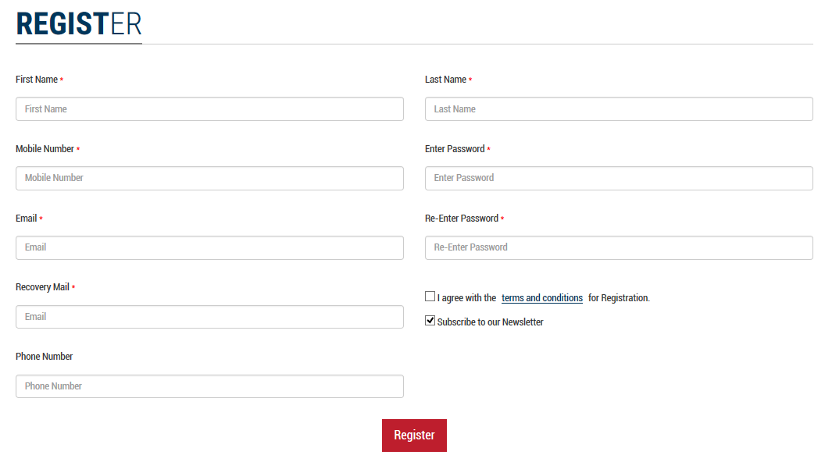

* + Upon confirmation of email, registered user will enter password and confirm password. User details with account ID will be added to User Table in our system
* User profile management
  + Registered user can Edit and Update Details like Personal information , delivery address, etc.
* My Account
  + After login , redirect to the my account page
  + In the Manage information under personal information, Full name ,Mobile no, Email are mandatory, phone number is an alternative option.

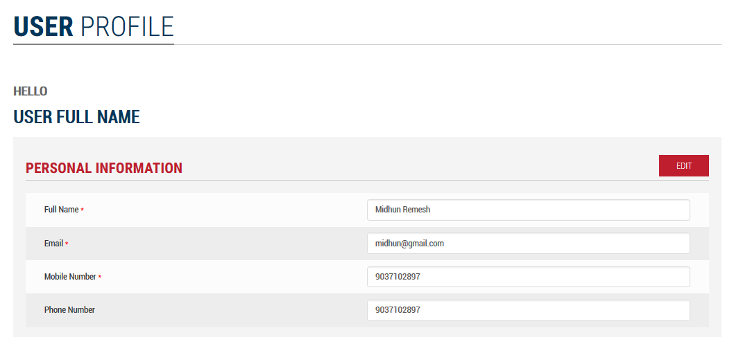

* + In the Delivery address form address name, area, governorate, block, street, building no, floor no, flat no, phone number is mandatory. Customer can edit and update the delivery address.

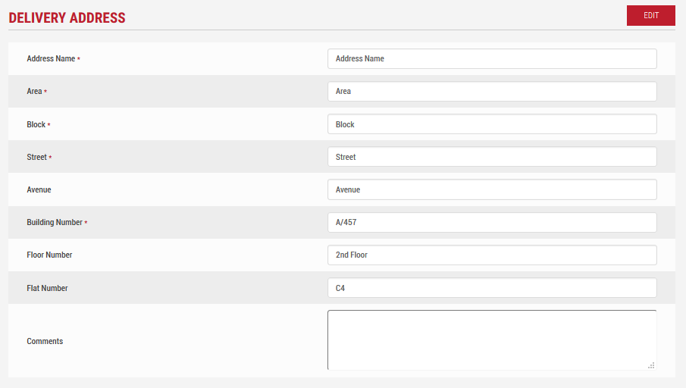

* + In the Shipping address book under my account, there are add new address button on the top of the address list. While clicking on add new address button a form will slide down to enter the new address book. Also there is an option to mark the address to be a default one. The default address should come first of the addresses list.

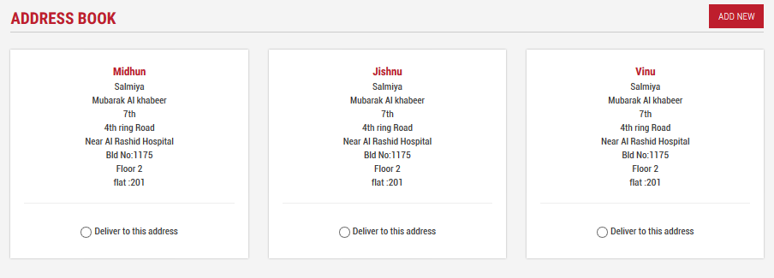

* + The following is add new delivery address form. If the customer doesn’t have a delivery address then this form will open and add new address it will be default address.

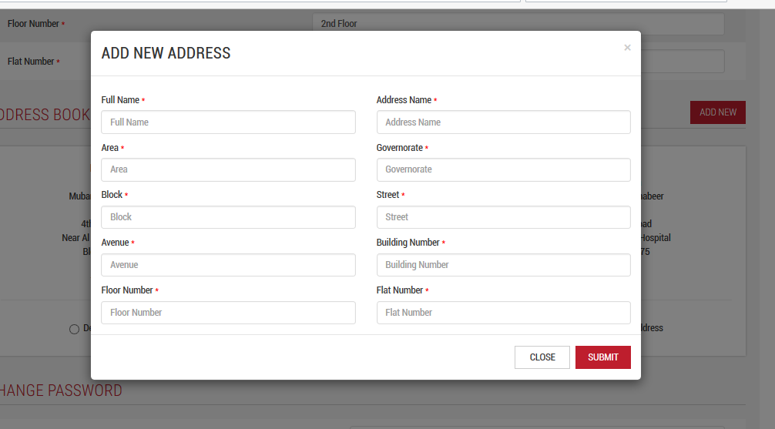

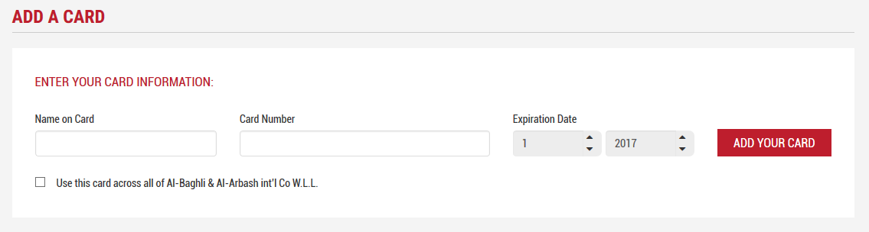

* + User can add their card details. This card details can be used at the payment time.
  + Order history under my account , split as two parts open order & previous order. Open orders contains orders which are not yet shipped.
  + Previous orders contains all the information related to the past orders. There is a repeater list with order no, order date, order status and order amount.
  + Customer can rate the order and write a review about the product / order
  + Orders can sort by newest, most rated,etc
  + Once we click on any of the order from the order list then it will redirect to the order details page. Order details page is showing invoice number, date, payment method, total quantity and total amount etc.
  + This page have a print option to take print of the corresponding order.

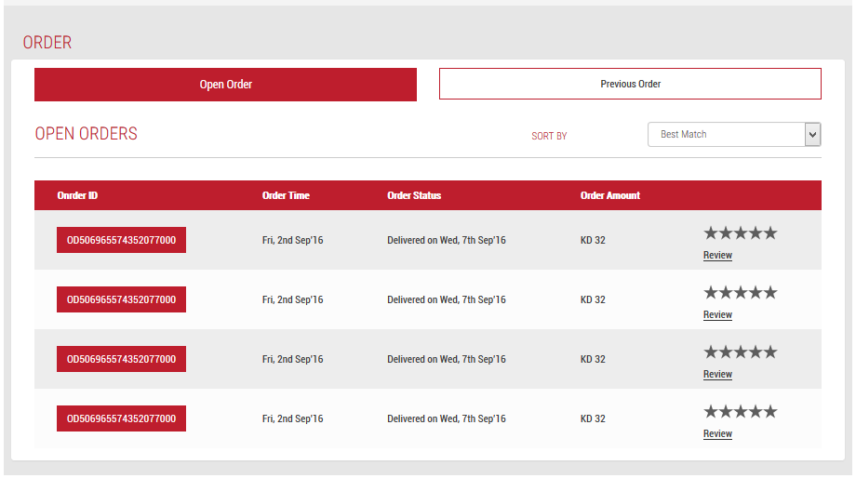

* + Change password under my account require the current password for updating new password.

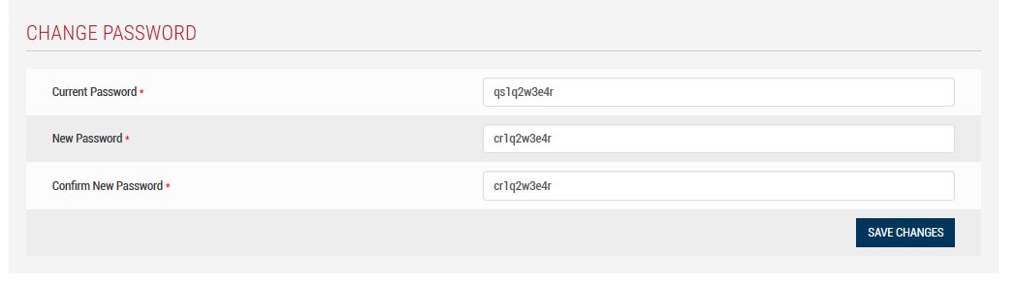

* Checkout process
  + User should login to the system to complete the checkout process
  + After adding items to the cart user can view cart items

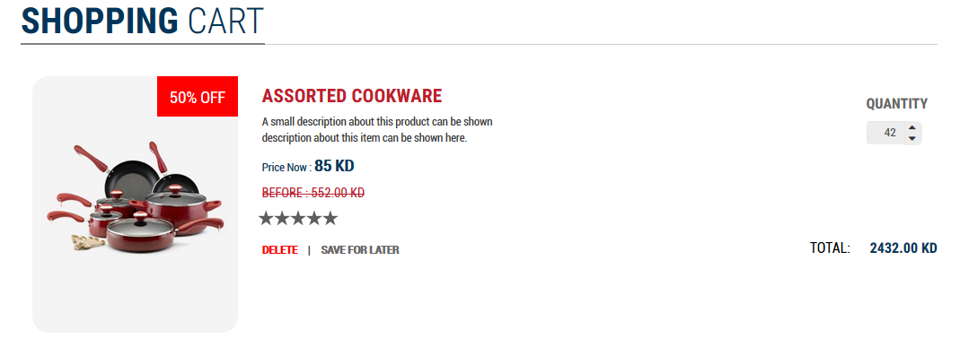

* + - Cart items should list
    - Rating votes like are added
    - Sale label (upper right) and % of sale if any sale is going on.
    - Customer can update the quantity by selecting the dropdown and up option.
    - Product options like colour and size is depends to the type of product category.
    - Delete and Save for later Functionality
    - If delivery charge of any item in the cart is free, then all items delivery charge will be free.
    - Admin can set Minimum order quantity/ price for products to proceed the checkout process.

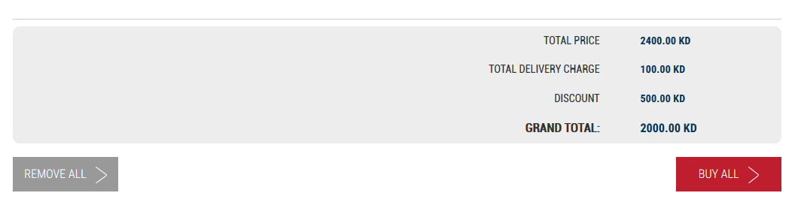

* + - Total Price, Total Delivery Charge, Discount and Grand Total should shown
    - Remove All option
    - Buy All should redirect to the checkout page/Review Order page

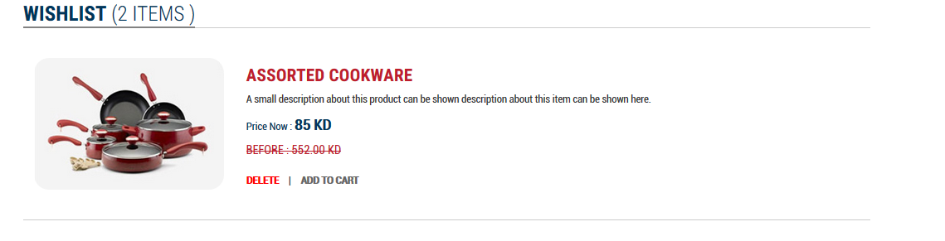

* + - Wish list items with paging should list in the shopping cart page.
  + In Review Order page, User can select any address that saved before from the Address name select box(Edit and Delete options available). If user select new address user can enter new address and when click on next button it’ll automatically save to the address book for future use

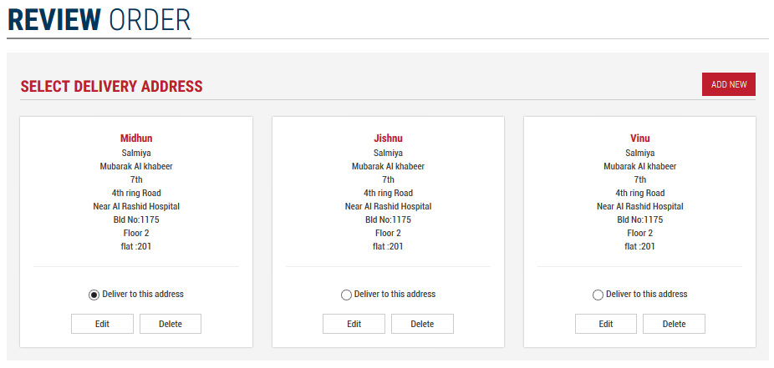

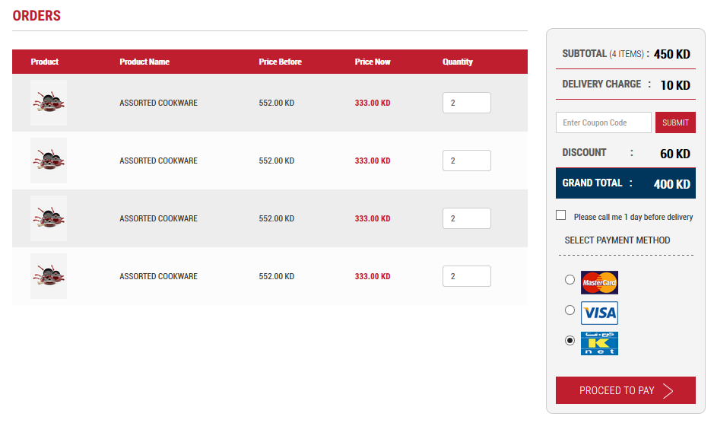

* + If delivery charge of any item in the cart is free, then all items delivery charge will be free.
  + Ability to redeem voucher code, by adding the voucher code and the discount

price from the code should be deducted from the total invoice price before proceeding to complete the payment

* + In the payment methods step, user can select knet,visa,mastercard and cash on delivery.Guest user cannot use payment method Cash On Delivery and then Proceed to Pay, it will redirect to the corresponding payment page.
  + After 3 days of product sale a mail should go to customer email id for rating and when they click us on star,it will redirect to review page which show the comment box and submit option. And the pop up thanks for your review!
  + There will be checkbox saying “Please call me 1 day before delivery”. If the user wants a call before product delivery, they need to check this checkbox.
* Login
  + Registered user who are already registered will enter user name and password
* Forgot password
  + Registered user who forgot password can reset password by specifying email ID
  + Registered user who forgot password and email can reset password by specifying alternate email ID
  + Registered user gets a reset password link where he can enter New Password and Confirm password.
* Administrator (Order Management)
  + Administrator can track all Order, update status like pending, dispatching and delivered
  + All these status update will send email notification for customers and will be updated in their order status
  + Administrator can export all transaction with date filtration
  + Administrator can deactivate registered user account

1. Order Processing Cycle

* Order reflection in Stock
  + Once registered or Guest user adds to shopping cart, confirms the payment method and proceeds to payment page, stock will be put as reserved.
  + Product after selecting payment method and Payment status is success, stock is updated in database
    - For Online payment, stock deduction will be done after payment gateway gives successful transaction status.
  + Transaction details will be updated to database.
* General Comments:
  + Special Request form for requesting a product that is not found on the website. It can also have attachments.
  + Advt. management: This will show related products on each product detailed page.
  + Later the admin can make offers or discounts to a certain category specifically.
  + Admin can make discount option for Products.
  + Admin can block the fake customer
  + If the user searches for something and he finds it out of stock, then there should be a button appearing for the user: “Request this item” so he can send to the admin telling him I need this, get it for me. User (Registered/ guest) can request this item. Guest User will fill contact details also. When the admin has stock, he can know who requested it and contact him.
  + For good customer/purchased high amount or recommended website, admin can mark it as VIP customer and can give special offer.
  + Email notifications: the user will receive email notifications for every step:
    - Register
    - Place new order + Order payment receipt (after delivery & payment)
    - Change in Profile (Password Change)
  + VIP Customer Functionality:
    - Requesting list of all Customers with total purchased amount above (X amount) that will be defined by admin
    - Admin have the privilege to add VIP flag for them all.
  + Service Rating Survey:
    - Once customer order delivered to him and the status of deliver “Completed” in the system, system will send a small survey to rate the service
  + Google Analytic Integration:
    - Integrate Google Analytics in Website

Administrator- Customer List

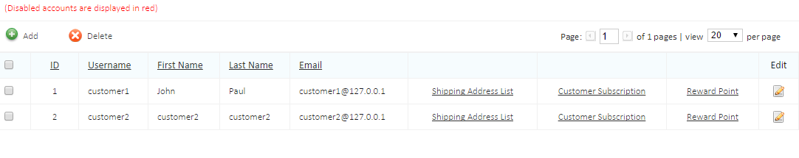

* Address can be managed from Admin Area
* Customers can be added for newsletter subscription

Ability to send email shot for:

* + - 1. VIP subscribed customers only
      2. Normal subscribed Customers
      3. All subscribed Customers
* Disabled users are listed in red like the following screen shot

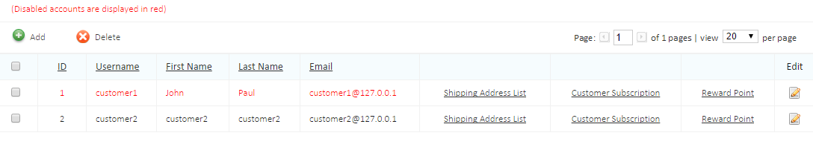

Best Seller

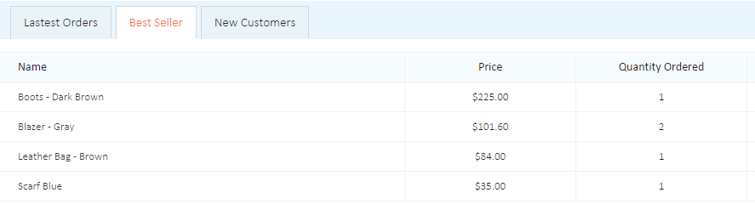

* Best seller will list all product assigned in best seller area

Administrator- Order Tracking

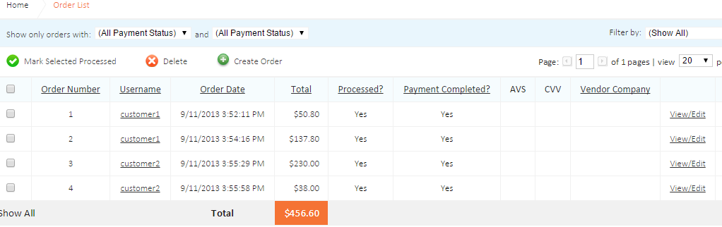

* This will list all orders received in this system
* All these orders can be exported to Excel
* Status can be added to all orders like pending, Processing , Delivered and Rejected
* On clicking each order, admin can find order details
* Once payment status is successful, order quantity will be removed from stock using web services.

Administrator- Report

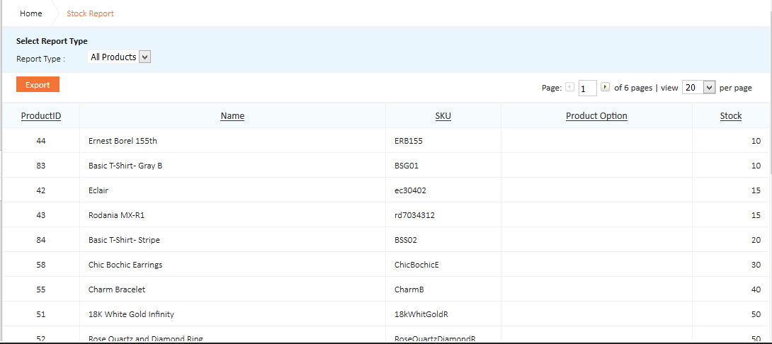

* **Sales Report**
  1. This report will display the sales for all products in system
  2. The report can be generated for :
     1. selected product name
     2. Selected category
     3. Or all
  3. The report will be generated for selected period:
     1. Daily: admin can select the day he would like to get the report for it
     2. Weekly:
        + 1. Select Year
          2. Select month
          3. Select week by choosing the period of the week or (1st week, 2nd week,..etc) 🡺 one of options will be applied
          4. The admin will get report of selected/all products within selected week/period
          5. Ability to select more than week and the result will show in the same report (for comparison purpose), each week will have list of most sold products
          6. report should categories the result of product list based on created categories in the system
     3. Monthly:
        + 1. Select Year
          2. Select month
          3. admin will get list of selected/all products within selected month
          4. Ability to select more than one month and the result will show in the same report (for comparison purpose)

report should categories the result of product list based on created categories in the system

* + 1. Yearly
       - 1. Select Year
         2. admin will get list of selected/all products within selected Year
         3. Ability to select more than one year and the result will show in the same report (for comparison purpose) 🡺 this will be based on the information saved in the database for the previous years (if any)

Report should categories the result of product list based on created categories in the system

* **Subscriber Report**
  1. This report will list all customer subscribed and created account in the system Only with the following information
  2. The list should contain both (VIP /normal ) Customers
  3. Admin have the ability to request report for :
     1. All subscribed customers
     2. VIP subscribed customers
     3. Normal subscribed customers
  4. The information will displayed in the report is

|  |  |  |
| --- | --- | --- |
| Customer Name | Type | Total Purchased amount |
| X | VIP | 500 KD |
| Y | Normal | 30 KD |

Admin will have the facility to block the customer and not to allow them to place order from the website.

* **Search Report**

This report will give the list of keywords used in website for searching product. Report will be based on Period

* 1. Today
  2. Last Month
  3. Last 30 Days
  4. Last 7 Days
  5. Yesterday
  6. Last 24 Hours
  7. This month
  8. This Year
  9. Custom – Specifying From date and To Date
* **Payment Report**

This report will give the list of payments received through shopping cart. Report will be based on Period

1. Today
2. Last Month
3. Last 30 Days
4. Last 7 Days
5. Yesterday
6. Last 24 Hours
7. This month
8. This Year
9. Custom – Specifying From date and To Date
10. per product, per brand, per category

* **Stock Availability Report**
  1. This report will be display only for the day admin use the function to request this report
  2. The result will be for :
     1. Either for selected category
     2. Or selected product name
     3. Or for all
  3. The report will have the following information

|  |  |  |  |  |
| --- | --- | --- | --- | --- |
| Category | Product name | Color | Size | Available Qty |
| X | X1 | Black | S | 10 |
|  |  |  | M | 20 |
|  |  |  | L | 15 |
|  |  | Red | M | 30 |
|  |  | White | L | 11 |
|  | X2 | Black | S | 12 |
|  |  | Red | M | 31 |
| Y | Y1 | White | S | 22 |
|  |  | Black | L | 10 |

* 1. The above table will be displayed based on selected period :
     1. Daily: admin can select the day he would like to get the report for it
* **Top Sellers Report** 
  1. The top selling products will be counted based on most purchased product
  2. The report should display the top 100 seller in following format as example:

|  |  |  |  |  |
| --- | --- | --- | --- | --- |
| Category | Product name | Color | Size | Qty Sold |
| X | X1 | Black | S | 10 |
|  |  |  | M | 20 |
|  |  |  | L | 15 |
|  |  | Red | M | 30 |
|  |  | White | L | 11 |
|  | X2 | Black | S | 12 |
|  |  | Red | M | 31 |
| Y | Y1 | White | S | 22 |
|  |  | Black | L | 10 |

* 1. The above table will be displayed based on selected period :
     1. Daily: admin can select the day he would like to get the report for
     2. Weekly:
        + 1. Select Year
          2. Select month
          3. Select week by choosing the period of the week or (1st week, 2nd week,..etc) 🡺 one of options will be applied
          4. The admin will get the report for listed top 100 seller product within selected week/period
          5. Ability to select more than week and the result will show in the same report (for comparison purpose), each week will have list of most viewed products
          6. report should categories the result of product list based on created categories in the system
     3. Monthly:
        + 1. Select Year
          2. Select month
          3. admin will get list of top 100 seller product within selected month
          4. Ability to select more than one month and the result will show in the same report (for comparison purpose)
          5. report should categories the result of product list based on created categories in the system
     4. Yearly
        + 1. Select Year
          2. admin will get list of top 100 seller product within selected Year
          3. Ability to select more than one year and the result will show in the same report (for comparison purpose) 🡺 this will be based on the information saved in the database for the previous years (if any)
          4. report should categories the result of product list based on created categories in the system
* **Top Ordered Customer Report**

Top order customers as value and as number of transaction. Comparison by

1. Weekly

B. Monthly

c. Yearly

* **Most Viewed Products Report**
  1. The view will be counted based on Click on Product to view the detail page of each product regardless if customer purchased or not the product
  2. The report should display the most 100 viewed products based on
     1. Daily: admin can select the day he would like to get the report for
     2. Weekly:
        + 1. Select Year
          2. Select month
          3. Select week by choosing the period of the week or (1st week, 2nd week,..etc) 🡺 one of options will be applied
          4. Admin will get the report for listed most 100 viewed product within selected week/period
          5. Ability to select more than week and the result will show in the same report (for comparison purpose), each week will have list of most viewed products
          6. Report should categories the result of product list based on created categories in the system
          7. The report should show the quantity sold of the product at the same period.
     3. Monthly:
        + 1. Select Year
          2. Select month
          3. Admin will get list of 100 viewed product within selected month
          4. Ability to select more than one month and the result will show in the same report (for comparison purpose)
          5. report should categories the result of product list based on created categories in the system
          6. The report should show the quantity sold of the product at the same period.
     4. Yearly
        + 1. Select Year
          2. Admin will get list of 100 viewed product within selected Year
          3. Ability to select more than one year and the result will show in the same report (for comparison purpose) 🡺 this will be based on the information saved in the database for the previous years (if any)
          4. Report should categories the result of product list based on created categories in the system

e. The report should show the quantity sold of the product at the same period.

* **Survey Report**

Report based on the surveys submitted by customers

a. Today

b. Last Month

c. Last 30 Days

d. Last 7 Days

e. Yesterday

f. Last 24 Hours

g. This month

h. This Year

i. Custom – Specifying From date and To Date

* **VIP Report**

Report should show VIP customers, who have frequently purchased products from the site/ purchased above a fixed rate.

a. Today

b. Last Month

c. Last 30 Days

d. Last 7 Days

e. Yesterday

f. Last 24 Hours

g. This month

h. This Year

i. Custom – Specifying From date and To Date

* **Most Rated Product Report**

a.Display top 100 rated products

b.List will display products as per their category list

c. Number of customers rated the product

d.The rating will be up to now only (the day which admin request the report from the system)

* **Customers Total Order Report**

List of customers total orders within

1. A day

b. A Selected week

c. A Selected Month

d. A Selected year

e. Most order Customer in value

* **Survey Report**

List of customers survey details with

a.Survey Answers,

b.Total Results

c.Comments

Note : Admin should be able to export all above reports in Excel format

User- Export

All Users registered in this cart can be exported to excel format

***Remarks: (if any)***

* Development will start after approving all website design templates.
* Signing this document confirms acceptance to this scope of work, any changes to this scope of work will be subject to a change request and would be evaluated on a case to case basis.

|  |  |  |
| --- | --- | --- |
|  | **Baghli & Arbash International** | **National Web Solutions Company** |
| **Approved By** |  |  |
| **Signature** |  |  |
| **Date** |  | 11 / 01 / 2017 |